DAT602 Report

## Game Description

The idea for my game is a multiplayer top down square grid map where players move between neighbouring 8 tiles (except when they are against the wall of the map) to collect items and gain score. All players are going to start on a ‘home tile’ that they will not be able to move back to once they leave. All the other tiles on the map will only be able to be moved to if another user is not already on them at that time. The map will be a ‘minesweeper’ style where there are numbers indicating where nearby traps are. Like minesweeper, the tiles will not be visible until one of the game users have moved to that tile, or an area that is not close to traps is opened up. If a player moves to a hidden tile that happens to have a trap on it, that player will be given a debuff (slow speed, loss of score, lose items). There will also be tiles on the map that contain items that will give users buffs (increase score, other user debuffs, powerup items) that will aid them in the game. Once every tile without a trap on has been cleared by the players of that game, the game will end and the user with the highest score wins.

# Story Board

## Login Screen

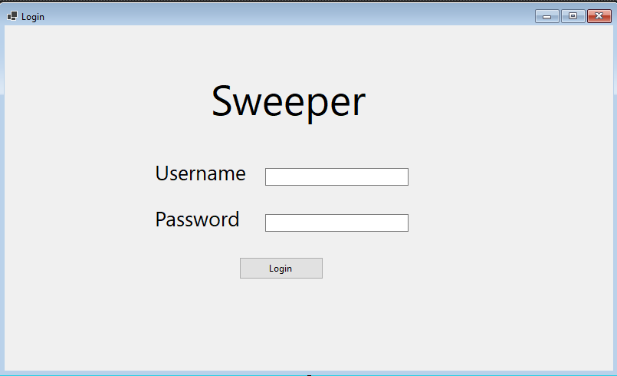

1.3

1.2

1.1

On the login screen the user will enter a username and a password. If the login fails 5 times the associated account will be locked and they will be prompted to contact an administrator.

* 1. – User enters a user name here
  2. User enters a password here
  3. Login button. If username exists in the database it will go on to the menu screen. If not the following dialogue box appears.

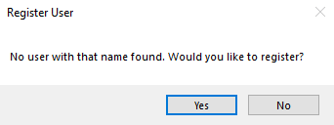

If the user clicks yes it will register the new user in the database and move on to the menu screen.

If the user fails to log in with the correct password 5 times the account will be locked and can only be unlocked by an administrator.

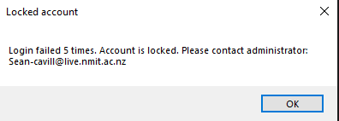

## 2. Menu

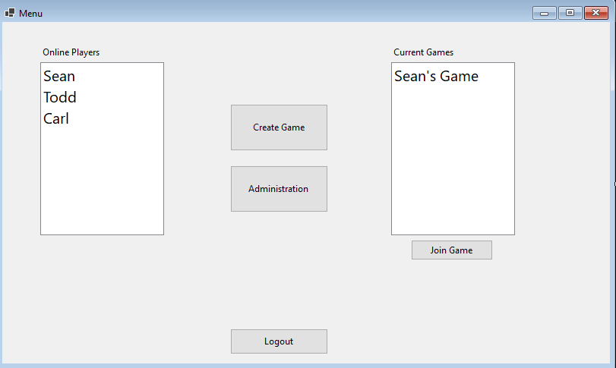

2.6

2.5

2.4

2.3

2.2

2.1

This is the menu screen where the user can see the online players, join a current game, create a game, and go to the administration screen if they have the privileges.

2.1 – List of online players

2.2 List of joinable games

2.3 – joins game if a game on the list is selected. Goes to the Game Story board.

2.4 – Create a game goes to the game story board.

2.5 – goes to administration tools(only available to admins)

2.6 – Logs the user out and returns to the login screen.

## 3. Game

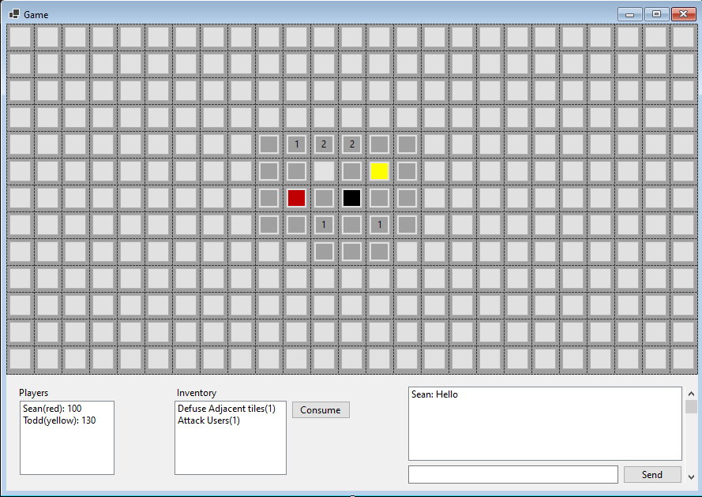

3.4

3.3

3.2

3.1

Game screens where users will play against each other. The map will show numbers near where trapped tiles are. There will be assets on the map users need to double click in order to add to their inventory. Other users are shown on the map as a coloured blob.

* 1. – Home tile where all the users will start.
  2. – Shows players, scores, and their colours.
  3. – Shows users inventory of items they can consume
  4. - Chat where users can send messages to each other.

## 4. Admin Tools

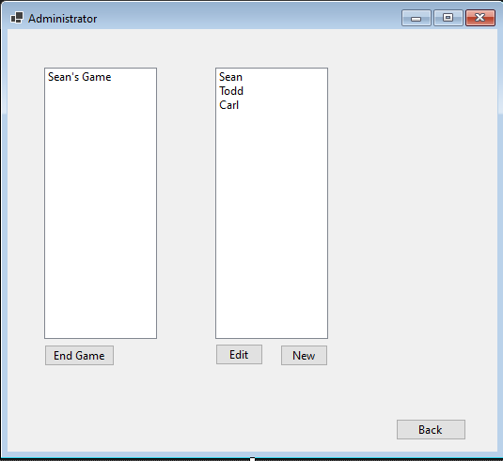

4.3

4.5

4.4

4.2

4.1

If an admin clicks on the administrate button on the home screen they will get to this administration page.

4.1 – Shows a list of active games

4.2 – Shows a list of registered users

4.3 ends currently highlighted game

4.4 Edits selected user goes to edit user screen

4.5 Goes to create new user screen

## 5. Edit user

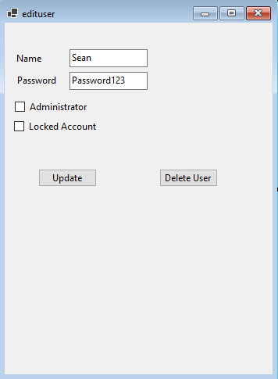

5.6

5.5

5.4

5.3

5.2

5.1

Edit user screen that is filled from the selected user. The admin can change the name, password, admin status, and locked status of the account.

5.1 – Name of the user

5.2 – Password of the account that can be changed.

5.3 – admin status of the user that if checked gives them administrator privileges.

5.4 – locked status of the user. Can be used to lock or unlock the account.

5.5 – updates the user record with the new information in the fields. Takes admin back to administration screen.

5.6 – deletes the user permanently takes admin back to administration screen.

## 6. New User

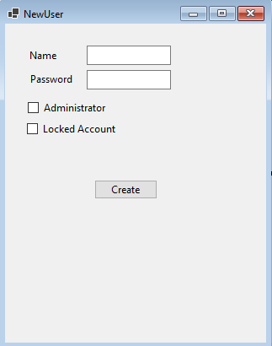

6.5

6.4

6.3

6.21

6.1

Screen for the admin to create a new user.

6.1 – Name of the user

6.2 – Password of the account

6.3 – admin status of the user that if checked gives them administrator privileges.

6.4 – locked status of the user. Can be used to lock or unlock the account.

6.5 – Creates the user and takes the admin back to the Administration screen.

## Logical diagram

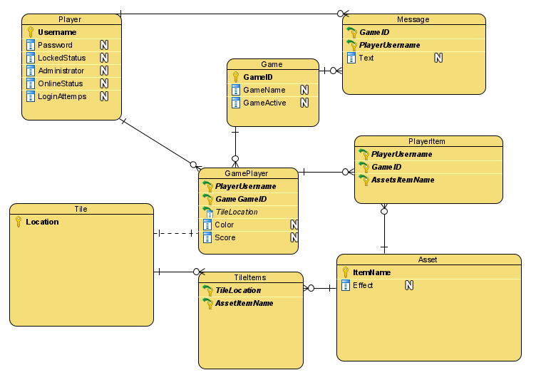

## Crud Table

|  |  |  |  |  |  |  |  |  |  |  |  |  |  |  |  |  |  |
| --- | --- | --- | --- | --- | --- | --- | --- | --- | --- | --- | --- | --- | --- | --- | --- | --- | --- |
| Entity/Attribute | Check Username | Register User | Validate Password | Lock Account | Log in | Log Out | Create Game | Join Game | Send message | Use Item | Move | Pick up item | Admin Access | Admin End Game | Admin Update user | Admin Delete user | Admin add new user |
| **Player** | R | C | R |  | U | U | R | R | R |  |  |  | R |  | RU | D | RC |
| Username | R | C | R |  |  |  | R | R | R |  |  |  |  |  | RU | D | RC |
| Password |  | C | R |  |  |  |  |  |  |  |  |  |  |  | RU | D | C |
| LockedStatus | R | C | R | U |  |  |  |  |  |  |  |  |  |  | RU | D | C |
| Administrator |  | C |  |  |  |  |  |  |  |  |  |  | R |  | RU | D | C |
| OnlineStatus | R | C |  |  | U | U |  |  |  |  |  |  |  |  | RU | D | C |
| Login Attempts | R | C |  |  | U |  |  |  |  |  |  |  |  |  |  | D | C |
| **GamePlayer** |  |  |  |  |  |  |  | CR |  | RU | R |  |  |  |  | D |  |
| Username |  |  |  |  |  |  |  | CR |  | R | R |  |  |  |  | D |  |
| GameID |  |  |  |  |  |  |  | CR |  | R | R |  |  |  |  | D |  |
| TileLocation |  |  |  |  |  |  |  | CR |  | R | R |  |  |  |  |  |  |
| Colour |  |  |  |  |  |  |  | CR |  | R | R |  |  |  |  |  |  |
| Score |  |  |  |  |  |  |  | CR |  | RU | R |  |  |  |  |  |  |
| **Tile** |  |  |  |  |  |  | C |  |  |  |  |  |  |  |  |  |  |
| Location |  |  |  |  |  |  | C |  |  |  |  |  |  |  |  |  |  |
| **TileItems** |  |  |  |  |  |  | C |  |  |  |  |  |  |  |  |  |  |
| TileLocation |  |  |  |  |  |  | C |  |  |  |  |  |  |  |  |  |  |
| ItemName |  |  |  |  |  |  | C |  |  |  |  |  |  |  |  |  |  |
| **Asset** |  |  |  |  |  |  |  |  |  | R |  | R |  |  |  |  |  |
| ItemName |  |  |  |  |  |  |  |  |  | R |  | R |  |  |  |  |  |
| Effect |  |  |  |  |  |  |  |  |  | R |  | R |  |  |  |  |  |
| **PlayerItem** |  |  |  |  |  |  |  |  |  | D |  | C |  |  |  | D |  |
| PlayerUserName |  |  |  |  |  |  |  |  |  | D |  | C |  |  |  | D |  |
| GameID |  |  |  |  |  |  |  |  |  | D |  | C |  |  |  | D |  |
| **Game** |  |  |  |  |  |  | C |  |  |  |  |  |  | R |  |  |  |
| GameID |  |  |  |  |  |  | C |  |  |  |  |  |  | R |  |  |  |
| GameName |  |  |  |  |  |  | C |  |  |  |  |  |  | R |  |  |  |
| GameActive |  |  |  |  |  |  | C |  |  |  |  |  |  | RU |  |  |  |
| **Message** |  |  |  |  |  |  |  | R | C |  |  |  |  |  |  |  |  |
| GameID |  |  |  |  |  |  |  | R | C |  |  |  |  |  |  |  |  |
| Username |  |  |  |  |  |  |  | R | C |  |  |  |  |  |  |  |  |
| Text |  |  |  |  |  |  |  | R | C |  |  |  |  |  |  |  |  |